**CSE 326 CA1 REPORT**

NAME- ABHISHEK KUMAR SINGH

REG.NO-12114530

ROLLNO. -RK21WYB57

SUBJECT-CSE326

TOPIC- WEBISTE ON MEMES SITE

TEACHER- MRS.ANKITA WADHAWAN

**INTRODUCTION:**

* My website topic is to make the **MEME SITE**, here I have made a memes site which contain lots of memes which you can share and like and also comment over that.

*It’s having collection of memes which are trending on Instagram, Facebook, Twitter and many more memes sharing platforms.

*It’s a child friendly website which contains child friendly memes.

*To make website look good and responsive **CSS AND JAVA SCRIPT** is used along with basic **HTML**.

**Total pages- 2;**

**Topic – A memes site;**

**Languages used- HTML, CSS AND JAVA SCRIPT;**

**Software used – Notepad;**

**Flow chart-**

**PAGE 1:**

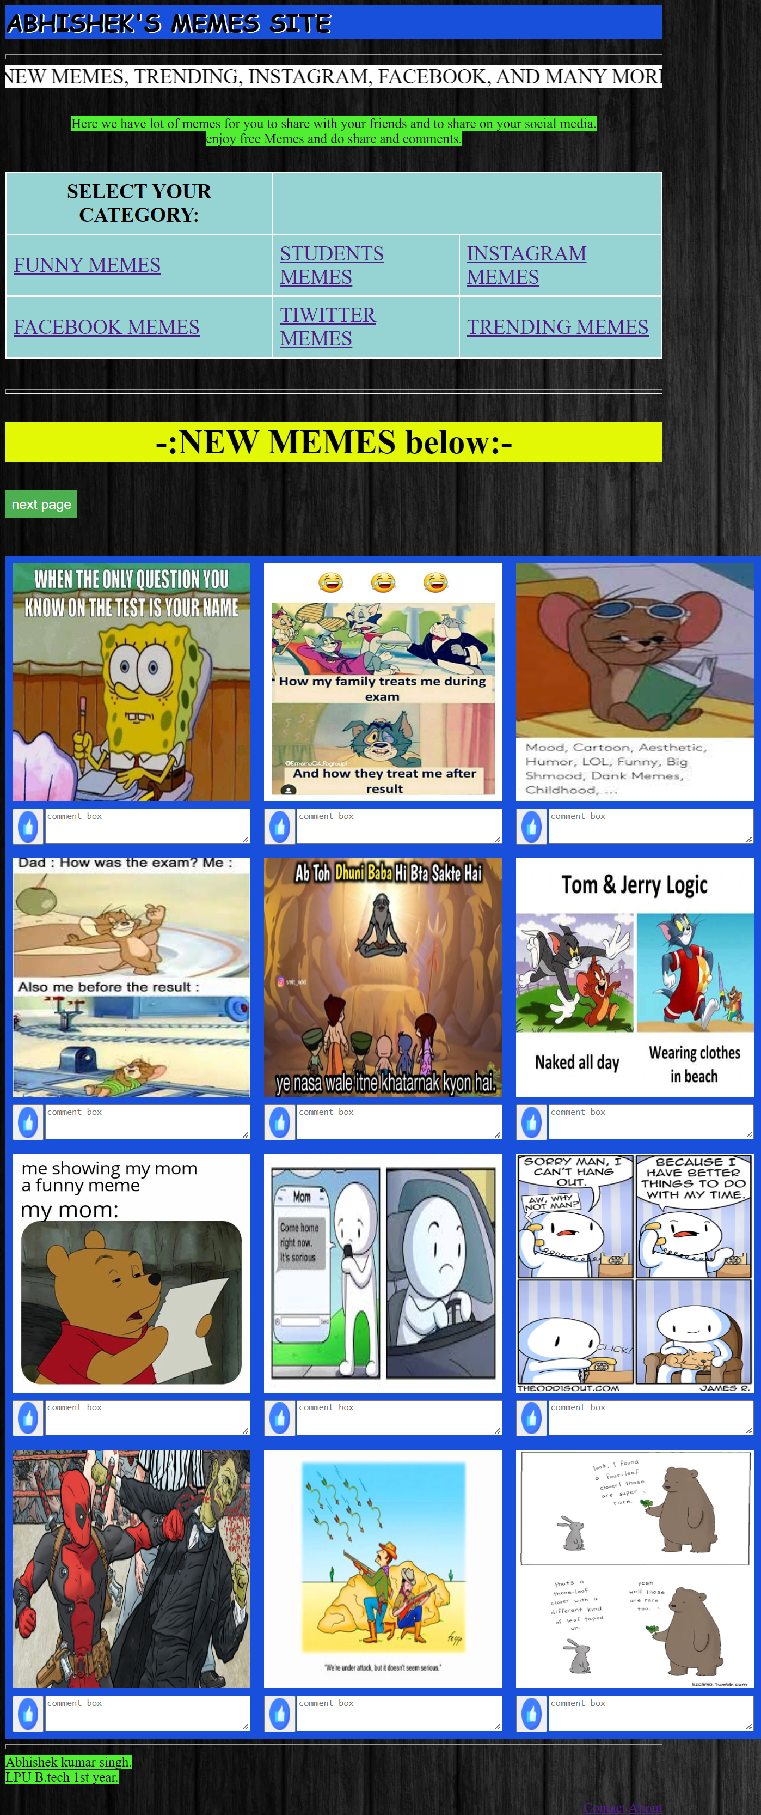 `

Tages used in above page:

Html:

1. <h1> for heading
2. <body bg scr= “image.jpg”>Page background image
3. <hr> for gap line
4. <marquee> for text animation
5. <hr> for gap line
6. <p> for paragraph
7. <table> for table
8. <a hyper> for hyperlink for external memes from google
9. <form> for making action button for next page.
10. Second table for image.
11. <img> for images for memes.

Css:

1. Heading background colour.
2. Heading font-size-color
3. Table background-color
4. Paragraphs bg-colour
5. Form button color

Java script:

1. Used for alert on pressing like button
2. Used for alert message for contact me and about button.

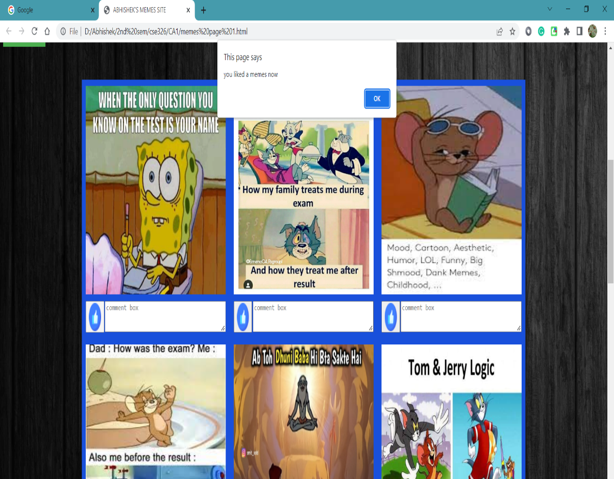**this image shows how J.S work when we press like button.**

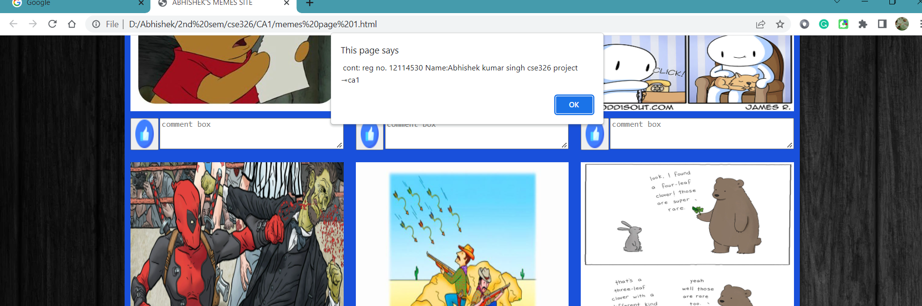

**This image shows how J.S works when we press contact and about button.**

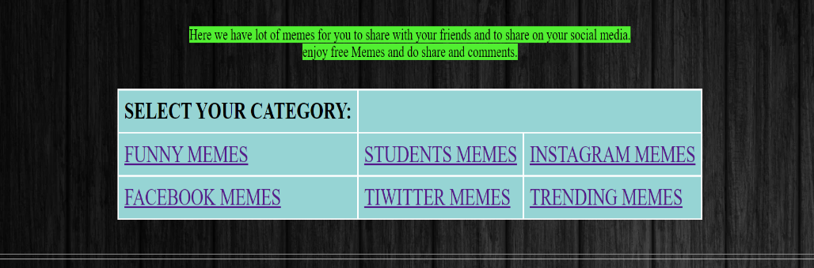**This image shows uses of hyperlinks by clicking those links you will be redirected to google images.**

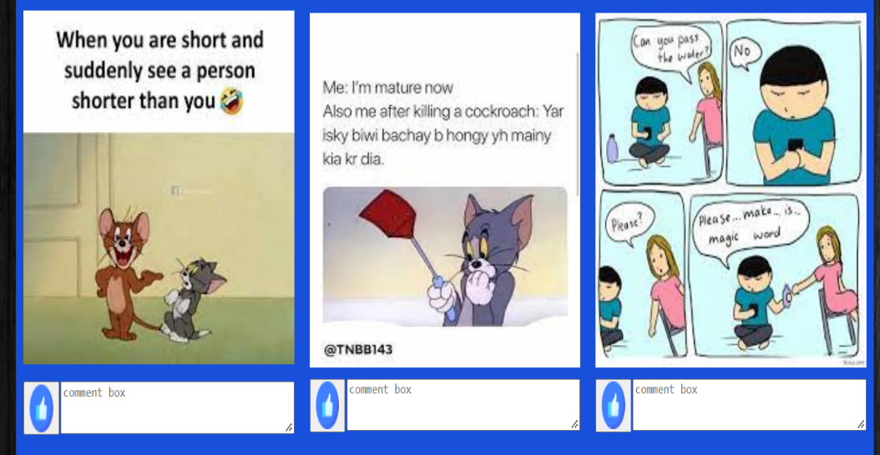

**This image shows use**

**Of form button tag**

**And text area tag use**

**For comments and likes**

**Pages2:**

Tages used in above page:

Html:

1. <h1> for heading
2. <body bg scr= “image.jpg”>Page background image
3. <hr> for gap line
4. <marquee> for text animation
5. <hr> for gap line
6. <p> for paragraph
7. <table> for table
8. <a hyper> for hyperlink for external memes from google
9. <form> for making action button for next page.
10. Second table for image.
11. <img> for images for memes.

Css:

1. Heading background colour.
2. Heading font-size-color
3. Table background-color
4. Paragraphs bg-colour
5. Form button color

Java script:

1. Used for alert on pressing like button
2. Used for alert message for contact me and about button.

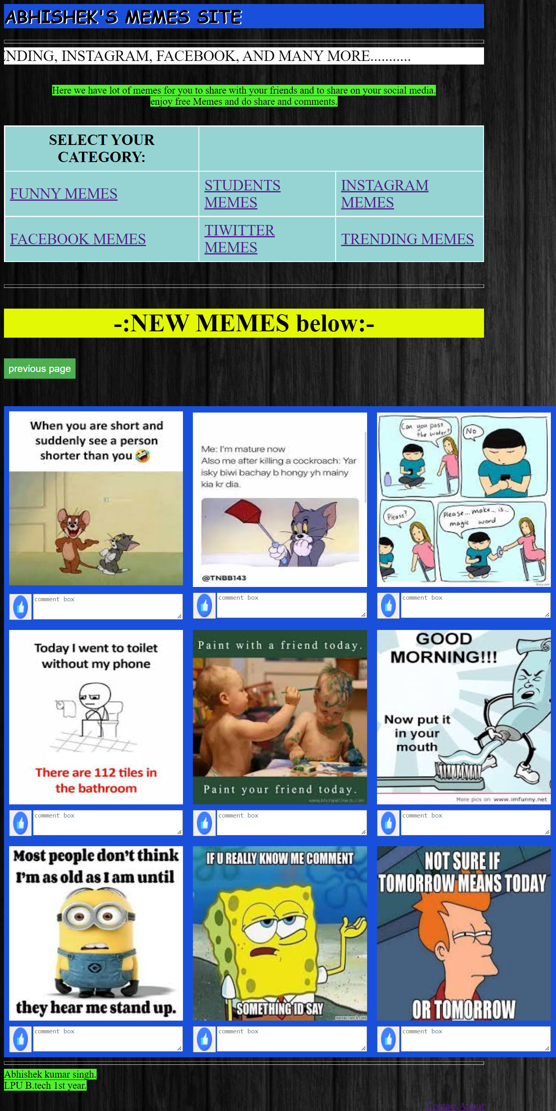

**THANK YOU**